PROPERTY INFORMATION PROJECT



PROJECT:Property Information Project

DURATION:September 2021 - October 2021

PROJECT BASED: Java Script Web Based Project

GOAL:Create a Better Website that Targets Specific

Audiences and is more user More Friendly

Content

1 INTRODUCTION 1

* 1. Property Information Web Based Project. 1
  2. Problem Statement 1
  3. Proposed System 1
  4. Goal 2

1. PROJECT PLAN 3
   1. Components Of The Project Plan Include 4
2. OPERATING ENVIRONMENT 6
3. PROTOTYPE OF THE SYSTEM 8
   1. Prototyping Process 8
   2. Aadvantages and Disadvantages 9
      1. Advantages 9
      2. Disadvantages 9
4. UML DESIGN 11
   1. Use Case Diagram 20
   2. Property Information Diagram 21
   3. Property Information Selection Page 22
   4. Property Information Choosing File Page.... ... 23
   5. The Next Page of Property Information  24

5.6 On Clicking to Check current Currency………………….……………...25

5.7 On giving input,it Automatically Calculates the Values………………..26

5.8 By giving Total Amount you can convert money…..…………………..27

1. CODING
   1. JavaScript 31
   2. jQuery 32
   3. Ajax 33
   4. Bootstrap 34
   5. Material Design 35
   6. XAMPP 36
   7. PHP 37
   8. MySQL 38
2. USER INTERFACE DESIGN, WARE HOUSES
   1. Property Information Page 40
   2. Property Information Calculation Page 41

8 FEEDBACK

8.1 Positive and Negative Feedback……….………………….…..59

8.1.1 Positive Feedback 59

8.1.2 Negative Feedback 60

8.1.3 GIT HUB code……………………………………………………………………………………………61

**Chapter 1**

**Introduction**

1.1 Property Information Web Based Project.

###### In this Website Project we have Designed for property Information.

Many property descriptions are short, uninteresting and loaded with facts and figures. There is a place for those numbers, but it’s not your property description.

This is prime real estate – the top block of text prospects will see when they land on your website and the most effective way to engage with them in the sales process.

A good description should be a narrative. It should tell the story of your property. It should focus on the emotions that the property and its amenities evoke. This is where you can describe the style of the property, the history of those who have operated there, and the importance of its place in the neighborhood.

You’re not just selling a property – you’re selling a component of another company’s brand. This property will become part of how they present themselves to prospects and customers. How will it do so?

Property description example:

*****Current Cap Rate: 4.7% | Market Cap Rate: 5.4% | Day-One Cash-on-Cash: 6.0%*****  
*As the exclusive listing advisor, the Bay Area Multifamily Group of Colliers international is pleased to present the opportunity to acquire a property in an highly demanded, in-fill location. Citadel Apartments is among the best located and best maintained properties in Rohnert Park, where a veritable hotbed of development is set in a family-oriented, values-focused neighborhood community. The property offers 22 two-bedroom units, all sitting on one quaint tree-lined parcel that totals over an acre in size. The property was built in 1976 and recently significantly upgraded by the current ownership.*

*Citadel Apartments boasts manicured landscaping and an ample amenity package. Parking is comprised of 44 total spaces, half of which are covered garages while the other half are lined surface spots. The property entrance is magnificently marked with a new wood trellis and cement walkway. That pathway accesses all units and, at its terminus, is a robust recreational area. The all new fire pit and barbecue area is the perfect poolside complement. Also adjacent to the pool is the all new fitness center.*

### **What are your responsibilities?**

Academies need the prior consent of the Secretary of State for most property transactions including land disposals, acquisitions, leases, easements and land charges. We act on behalf of the Secretary of State as the Department for Education’s (DFE) agency for funding and compliance.

Your responsibilities are set out in:

* the [academies financial handbook](https://www.gov.uk/government/publications/academies-financial-handbook-2013)
* your funding agreement
* Schedule 1 of the Academies Act 2010

They require you to:

* place a restriction against the title of any land owned by the trust at the Land Registry in favour of the Secretary of State
* have consent of the Secretary of State in order to make any change to that restriction
* notify the Secretary of State of your intention to dispose of any publicly funded land (or buildings) prior to agreeing to the disposal, and to proceed with the disposal only after you have that consent
* have prior consent to buying land or buildings or taking out a lease of 5 or more years

Without consent, your purchaser, lessee, grantee or any other party will not be able to register their legal interest in the land and you may be liable to pay damages for any losses caused.

You are also responsible for obtaining all other relevant consents needed under the planning acts, building regulations and health and safety legislation, any superior landlord or local authority.

1.2 PROPOSED SYSTEM

[Commercial real estate marketing](https://www.sharplaunch.com/blog/commercial-real-estate-marketing-strategy/) requires considered investment in a number of resources, but one of the most important is the property description that sits at the center of your campaign.

To guide you in crafting a high quality, results-oriented property description, we’ve outlined the core elements you should include along with real property description examples that you can use as a template for marketing your next property.

With the right approach to your target audience, location, and property description best practices, you can produce an enhanced property description that generates more leads and helps existing prospects find the information they need quickly.

## **How to Write a Property Description**

Your commercial real estate description is a summary of everything that matters most about the property.

This is where you tell the story of your property, the location and amenities of the property, and any other relevant details.

Imagine you are having a conversation with a prospect.

What details would you highlight when introducing the property to them?

Below we’re outlined 5 major elements and 8 useful tips that can help you optimize your property descriptions along with concrete examples you can use for inspiration.

**Chapter 2**

**PROJECT PLAN**

One of the critical factors for project success is having a well-developed project plan.

1 Explain the project plan to key stakeholders and discuss its key components. One of the most misunderstood terms in project management, the project plan is a set of living documents that can be expected to change over the life of the project. Like a roadmap, it provides the direction for the project. And like the traveler, the project manager needs to set the course for the project, which in project management terms means creating the project plan.

2 A common misconception is that the plan equates to the project timeline, which is only one of the many components of the plan. The project plan is the major work product from the entire planning process, so it contains all the planning documents for the project.

3 Related Article Typically many of the projects key stakeholders, that is those affected by both the project and the projects end result, do not fully understand the nature of the project plan. Since one of the most important and difficult aspects of project management is getting commitment and buying, the first step is to explain the planning process and the project plan to all key stakeholders. It is essential for them to understand the importance of this set of documents and to be familiar with its content, since they will be asked to review and approve the documents that pertain to them.

# 2.1 Components Of The Project Plan Include

Baselines Baselines are sometimes called performance measures, because the performance of the entire project is measured against them.They are the projects three approved starting points and include the scope, schedule.

1.Baselines: Baselines are sometimes called performance measures, because the performance of the entire project is measured against them. They are the project’s three approved starting points and include the scope, schedule, and cost baselines. These provide the ’stakes in the ground.’ That is, they are used to determine whether or not the project is on track, during the execution of the project.

2.Baseline management plans:These plans include documentation on how variances to the base- lines will be handled throughout the project. Each project baseline will need to be reviewed and managed. A result of this process may include the need to do additional planning, with the possibility that the baseline(s) will change. Project management plans document what the project team will do when variances to the baselines occur, including what process will be followed, who will be notified, how the changes will be funded, etc.

3.Define roles and responsibilities: Not all key stakeholders will review all documents, so it is necessary to determine who on the project needs to approve which parts of the plan.

4.Some of the key players are:Project sponsor, who owns and funds the entire project. Sponsors need to review and approve all aspects of the plan. Designated business experts, who will define their requirements for the end product. They need to help develop the scope baseline and approve the documents relating to scope. They will be quite interested in the timeline as well. Project manager, who creates, executes, and controls the project plan. Since project managers build the plan, they do not need to approve it. Project team, who build the end product. The team needs to participate in the development of many aspects of the plan, such as identifying risks, quality, and design issues, but the team does not usually approve it. End users, who use the end product.

5.Develop scope baseline: Once the deliverable are confirmed in the Scope Statement, they need to be developed into a work breakdown structure (WBS), which is a decomposition of all the deliverable in the project. This deliverable WBS forms the scope baseline and has these elements The WBS is often thought of as a task breakdown, but activities and tasks are a separate breakdown, identified in the next step

6.Create baseline management plans: Once the scope, schedule, and cost baselines have been established, you can create the steps the team will take to manage variances to these plans. All these management plans usually include a review and approval process for modifying the baselines. Different approval levels are usually needed for different types of changes.

7.In addition, not all new requests will result in changes to the scope, schedule, or budget, but a process is needed to study all new requests to determine their impact to the project.

8.Develop the staffing plan: The staffing plan is a chart that shows the time periods, usually month, quarter, year, that each resource will come onto and leave the project. It is similar to other project management charts, like a Grant chart, but does not show tasks, estimates, begin and end dates, or the critical path. It shows only the time period and resource and the length of time that resource is expected to remain on the project.

**Chapter 3**

**OPERATING ENVIRONMENT**

In computer software,an operating environment or integrated applications environment is the environment in which users run application software. The environment consists of a user interface provided by an applications manager and usually an application programming interface (API) to the applications manager. An operating environment is usually not a full operating system but is a form of middleware that rests between the OS and the application.For example, the first version of Microsoft Windows, Windows 1.0, was not a full operating system, but a GUI laid over DOS albeit with an API of its own. Similarly, the IBM U2 system operates on both Unix Linux and Windows NT. Usually the user interface is text based or graphical, rather than a command-line interface DOS or the Unix shell), which is often the interface of the underlying operating system.A Standard Operating Environment (SOE) is a standard implementation of an operating system and its associated software. Associated names and concepts include MOE Managed Operating Environment. COE Consistent or Common Operating Environment. MDE Managed Desktop Environment.

In science and engineering, a system is the part of the universe that is being studied, while the environment is the remainder of the universe that lies outside the boundaries of the system. It is also known as the surroundings or neighborhood, and thermodynamics,

As the reservoir.a system is the part of the universe that is being studied, while the environment is the remainder of the universe that lies outside the boundaries of the system. It is also known as the surroundings or neighborhood, and in thermodynamics, as the reservoir. Depending on the type of system, it may interact with the environment by exchanging mass, energy (including heat and work), linear momentum, angular momentum, electric charge, or other conserved properties. In some disciplines, such as information theory, information may also be exchanged. The environment is ignored in analysis of the system, except in regard to these interactions. Examining the industry environment needs an appraisal of the competitive structure of the organizations industry, including the competitive position of a particular organization and its main rivals. Also, an assessment of the nature, stage, dynamics and history of the industry is essential. It also implies evaluating the effect of globalization on competition within the industry. Analyzing the national environment needs an appraisal of whether the national framework helps in achieving competitive advantage in the globalized environment. Analysis of macro-environment includes exploring macro-economic, social, government, legal, technological and international factors that may influence the environment. The analysis of organizations external environment reveals opportunities and threats for an organization. Strategic managers must not only recognize the present state of the environment and their industry but also be able to predict its future positions

**Chapter 4**

**PROTOTYPE OF THE SYSTEM**

A prototype is an early sample, model, or release of a product built to test a concept or process or to act as a thing to be replicated or learned from. It is a term used in a variety of contexts, including semantics, design, electronics,and software programming. Software prototyping is the activity of creating prototypes of software applications, i.e., incomplete versions of the software program being developed. It is an activity that can occur in software development and is comparable to prototyping as known from other fields, such as mechanical engineering or manufacturing. A prototype typically simulates only a few aspects of, and may be completely different from, the final product. Prototyping has several benefits: The software designer and implementer can get valuable feedback from the users early in the project. The client and the contractor can compare if the software made matches the software specification, according to which the software program is built. It also allows the software engineer some insight into the accuracy of initial project estimates and whether the deadlines and milestones proposed can be successfully met. The degree of completeness and the techniques used in the prototyping have been in development and debate since its proposal in the early 1970s. The original purpose of a prototype is to allow users of the software to evaluate developers’ proposals for the design of the eventual product by actually trying them out, rather than having to interpret and evaluate the design

based on descriptions. Prototyping can also be used by end users to describe and prove requirements that have not been considered, and that can be a key factor in the commercial relationship between developers and their clients.Interaction design in particular makes heavy use of prototyping with that goal.

# Prototyping Process

The process of prototyping involves the following steps

* + 1. Identify basic requirements Determine basic requirements including the input and output information desired. Details, such as security, can typically be ignored.
    2. Develop initial prototype The initial prototype is developed that includes only user inter- faces. See Horizontal Prototype, below
    3. Review The customers, including end-users, examine the prototype and provide feedback on additions or changes.
    4. Revise and enhance the prototype Using the feedback both the specifications and the prototype can be improved. Negotiation about what is within the scope of the contract product may be necessary. If changes are introduced then a repeat of steps 3 and 4 may be needed.Identify basic requirements Determine basic requirements including the input and output information desired. Details, such as security, can typically be ignored.
    5. Develop initial prototype The initial prototype is developed that includes only user inter- faces. See Horizontal Prototype, below

6.Review The customers, including end-users, examine the prototype and provide feedback on additions or changes.

Revise and enhance the prototype Using the feedback both the specifications and the prototype can be improve

7 Negotiation about what is within the scope of the contract product may be necessary. If changes are introduced then a repeat of steps 3 and 4 may be needed

4.2 Advantages and Disadvantages

## 4.2.1 Advantages

There are many advantages to using prototyping in software development some tangible some abstract.

Reduced time and costs Prototyping can improve the quality of requirements and specifications provided to developers. Because changes cost exponentially more to implement as they are detected later in development, the early determination of what the user really wants can result in faster and less expensive software.

Improved and increased user involvement Prototyping requires user involvement and allows them to see and interact with a prototype allowing them to provide better and more complete feedback and specifications.

## 4.2.2 Disadvantages

Using, or perhaps misusing, prototyping can also have disadvantages.

Insufficient analysis The focus on a limited prototype can distract developers from properly analyzing the complete project. This can lead to overlooking better solutions, preparation of incomplete specifications or the conversion of limited prototypes into poorly engineered final projects that are hard to maintain.

User confusion of prototype and finished system Users can begin to think that a prototype, intended to be thrown away, is actually a final system that merely needs to be finished or polished.

# 

# 4.3 Open issues

Entries must be clarified before final sign-off (so 3.1 Open Issues chapter should be empty then).

## Open Issues

|  |  |  |  |
| --- | --- | --- | --- |
| **Issue #** | **Chapter** | **Issue** | **Comments** |
|  |  |  |  |
|  |  |  |  |
|  |  |  |  |

## Closed Issues

|  |  |  |  |
| --- | --- | --- | --- |
| **Issue #** | **Chapter** | **Issue** | **Comments** |
|  |  |  |  |
|  |  |  |  |

# 

# 4.4 Customer Requirements

## 4.4.1 Business Background

### Main Process

Create and implementing a Website for BASF Iran company to facilitate the local business with a Digital face for the market.

## 4.4.2 New Authorizations / Change Authorizations

In the website the following user-roles are required:

* Website administrator
* BASF employee users
* External users
  + Customer
  + 3rd vendors

## 

## 4.5.1 Business Requirements

BASF Iran business will include below info in its website:

Product information including Product list, Technical data sheets, Product Finder and Packaging type

* Industry Clustering & Contact details by industry, Function & Department
* Survey for customers
* BASF Iran specific History via Movies and Pics
* Global events update – publicly announced events worldwide
* promotion of new products in Social Media (CMS)
* News events and updates bar/page (CMS)
* Sustainability awareness for Iran on the web front (CMS)
* Digital marketing Analytics research in visitors’ analysis & reports
* Customer Form inquiry on products
* Newly registered launch of Products
* Shared trial results in the website
* Local Merchandise marketing
* Current customer enrollment and order history
* Customer Dashboard
* Trade control check - PPL & SPL, EUD & VCP, US Sheet (if applicable)
* Customer registration process (SC)

## 

## 4.5.2 Security Requirements

Description of the security requirements, which are defined in the [Information Security Policy Framework](http://www.information-services-and-supply-chain-operations.basf.net/it-is/gs/en_GB/content/solutions/it-security/policy_framework/Security_Policies_Overview) necessary to protect BASF proprietary information. A “security concept” template is provided in the Security Enablement section.

Note: To determine whether the project is security relevant, answer these [security consideration questions](http://www.information-services-and-supply-chain-operations.basf.net/it-is/gs/en/function/conversions:/publish/content/solutions/it-security/itrm/Documents/Security_Consideration_Questions.pdf) during the Initiation phase of the project.

Data Classification: Public

Security questions

New technology 🡪 yes

Business Impact > 🡪 yes

Internet facing 🡪 Yes

Confidential Information 🡪 No

**Property UI Design**

# User Guide Diagram

# guide 1

# 

# Property Information Diagram

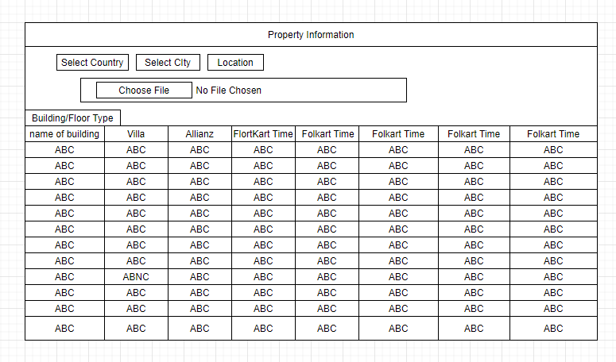

# 5.3 Property Information Selection Page

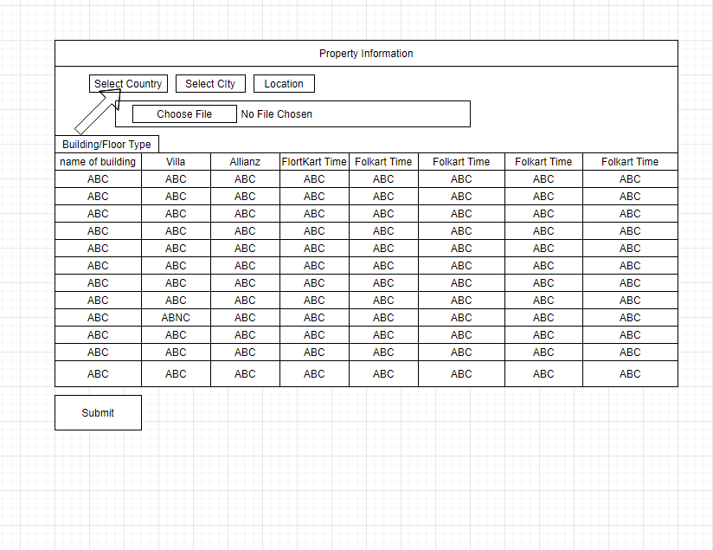

# Property Information Choosing File Page

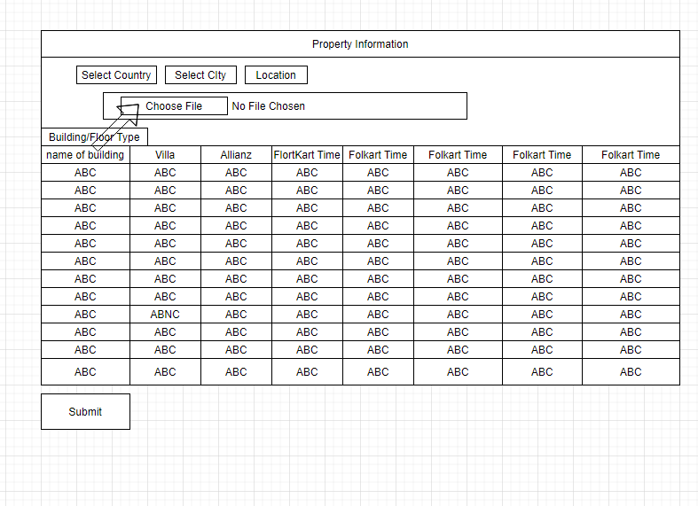

# 

# Property Information Submitting Page

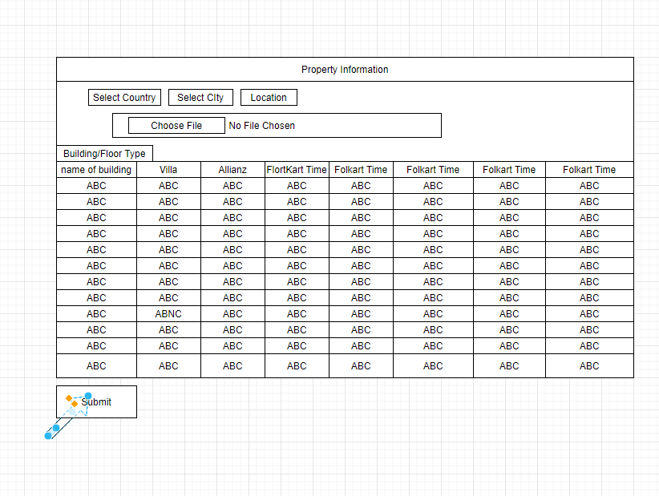

# 

# 5.6 The Next Page of Property Information

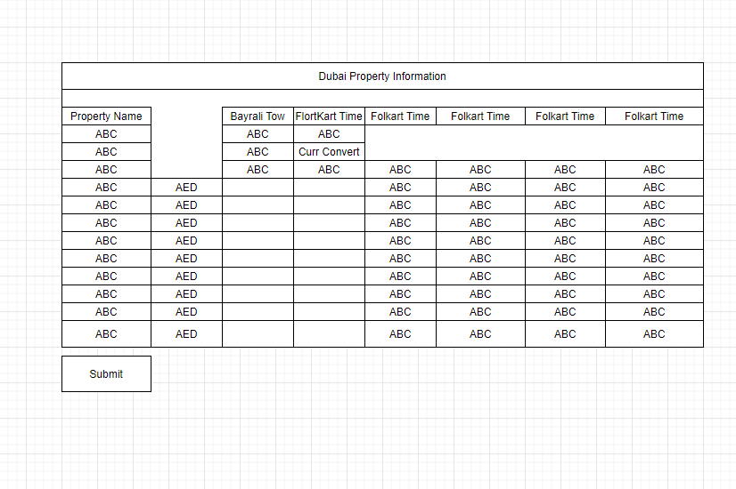

# 

# 

# 5.7 On Clicking to Check the Current Currency

# 6.diagram

# 5.8 On giving input,it Automatically Calculates the Values

# 7.diagram

# 5.9 By giving Total Amount you can convert money

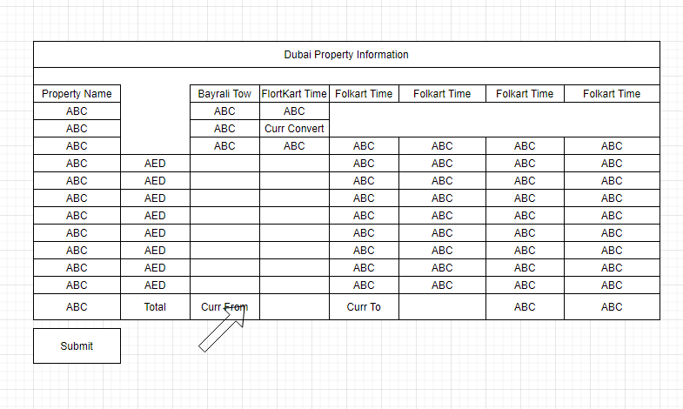

**Chapter 6**

**CODING**

# JavaScript

JavaScript is a programming language that is run by most modern browsers. It supports object- oriented programming and procedural programming. It can be used to control web pages on the client side of the browser, server-side programs, and even mobile applications.

You probably heard about JavaScript before. It borrows the name of the popular programming language Java, and it has a catchy sound to it. That’s why the name was chosen! The language isn’t really related to Java, but it rides on the popular name. This language is used commonly in combination with HTML, CSS, and AJAX.

Chances are that the page you are looking at right now contains the code for JavaScript. While HTML markup language allows web developers to format content, JavaScript allows them to make the page dynamic. JavaScript allows for changing text on the page, creating pop-up messages, and validating text in text boxes to make sure required fields have been filled. JavaScript makes web pages more dynamic by allowing users to interact with web pages, click on elements, and change the pages.

# J Query

J Query is a fast, small, and feature-rich JavaScript library. It makes things like HTML document traversal and manipulation, event handling, animation, and Ajax much simpler with an easy-to-use API that works across a multitude of browsers. With a combination of versatility and extensibility,j Query is not a language, but it is a well written JavaScript code. As quoted on official j Query website, ”it is a fast and concise JavaScript Library that simplifies

HTML document traversing, event handling, animating, and Ajax interactions for rapid web development”.

J Query is very compact and well written JavaScript code that increases the productivity of the developer by enabling them to achieve critical UI functionality by writing very small amount of code.

1. It helps to improve the performance of the application
2. It helps to develop most browser compatible web page
3. It helps to implement UI related critical functionality without writing hundreds of lines of codes
4. It is fast
5. It is extensible j Query can be extended to implement customized behavior

No need to learn fresh new syn taxes to use j Query, knowing simple JavaScript syntax is enough Simple and cleaner code, no need to write several lines of codes to achieve complex functionality

# Ajax

Ajax is a client-side script that communicates to and from a server/database without the need for a postback or a complete page refresh. The best definition I’ve read for Ajax is the method of exchanging data with a server, and updating parts of a web page without reloading the entire page.

# Bootstrap

Bootstrap is a free and open-source front-end web framework for designing websites and web applications. It contains HTML- and

CSS-based design templates for typography, forms, but- tons, navigation and other interface components, as well as optional JavaScript extensions. Unlike many web frameworks, it concerns itself with front-end development only.

1. bootstrap CSS framework
2. bootstrap JavaScript jQuery framework
3. glyphicons a font (an icon font set)

Additionally, Bootstrap requires jQuery to function. jQuery is an extremely popular and widely used JavaScript library, that both simplifies and adds cross browser compatibility to JavaScript.

# 6.5 Material Design

Material Design is a Googles conceptual design philosophy that outlines how apps or web should look and work on mobile devices. It breaks down everything such as animation, style, layout and gives guidance on patterns, components and usability. Material design is Googles idea of how websites and apps should look and operate across all devices. Essentially, it combines the standard elements of good web design with the capabilities of modern technology and science. Material starts with mobile but extends to any other device.

1. Realistic visual cues: The design is grounded in reality and actually inspired by design with paper and ink.
2. Bold, graphic and intentional: Fundamental design techniques drive the visuals. 3.Motion provides meaning: Animation is a key component of Material Design. 4.Understanding the Tactile Surface:

Think of this as having multiple sheets of paper that are stacked together to create a framework for how everything within the design works. These sheets are a little different from physical sheets of paper in that they can change shape and form such as stretch or bend but work in a way that is seemingly realistic.

# XAMPP

XAMPP is the most popular PHP development environment! XAMPP is an Apache server distribution which has MySQL, PHP, PERL, and some other softwares like phpMyAdmin. XAMPP stands

for Cross-Platform (X), Apache (A), MySQL (M), PHP (P) and Perl (P). It is a simple, lightweight Apache distribution that makes it extremely easy for developers to create a local web server for testing purposes.

1. download the correct version for your environment form the official site of xampp
2. install the software using the give instructions.
3. open the control panal of the xampp.
4. start the mysql and apache server.
5. go to the htdoc of the xampp installed directory.
6. put your project and run it from the web browser using the localhost address.
7. phpmyadmin allows you to manage the all database.

# 6.6 PHP

As of version 3, it stands for PHP Hypertext pre-processor. It is a general purpose server side scripting language that is used to develop.

1. Static websites.
2. Dynamic websites.
3. Web applications.

HTML is an added advantage when learning PHP Language. You can even learn PHP with- out knowing HTML but its recommended you at least know the basics of HTML. Database management systems DBMS for database powered applications. For more advanced topics such as interactive applications and web services, you will need JavaScript and XML.

1. PHP is open source and free.
2. Short learning curve compared to other languages such as JSP, ASP etc.
3. Large community document
4. Most web hosting servers support PHP by default unlike other languages such as ASP that need IIS. This makes PHP a cost effective choice.
5. PHP is regular updated to keep abreast with the latest technology trends.
6. PHP is cross platform; this means you can deploy your application on a number of different operating systems such as windows, Linux, Mac OS etc.

# 

# MySQL

MySQL is an open source relational database management system (RDBMS) based on Struc- tured Query Language (SQL). LAMP is a Web development platform that uses Linux as the

operating system, Apache as the Web server, MySQL as the relational database management system and PHP as the object-oriented scripting language.

MySQL runs on virtually all platforms, including Linux, UNIX, and Windows. Although it can be used in a wide range of applications, MySQL is most often associated with web-based applications and online publishing and is an important component of an open source enterprise stack called LAMP. LAMP is a Web development platform that uses Linux as the operating system, Apache as the Web server, MySQL as the relational database management system and PHP as the object-oriented scripting language.

1. Data Security
2. On-Demand Scalability
3. High Performance
4. Round-the-clock Uptime
5. Comprehensive Transactional Support
6. Complete Workflow Control
7. Reduced Total Cost of Ownership
8. The Flexibility of Open Source

**Chapter 7**

**User Interface Design**

# Property Information Page

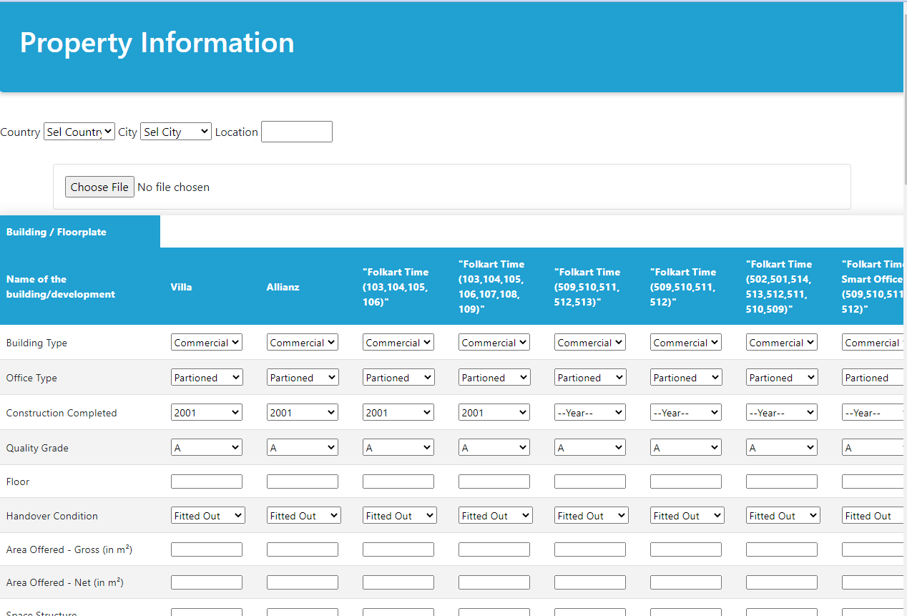

# 

# Property Information Calculation Page

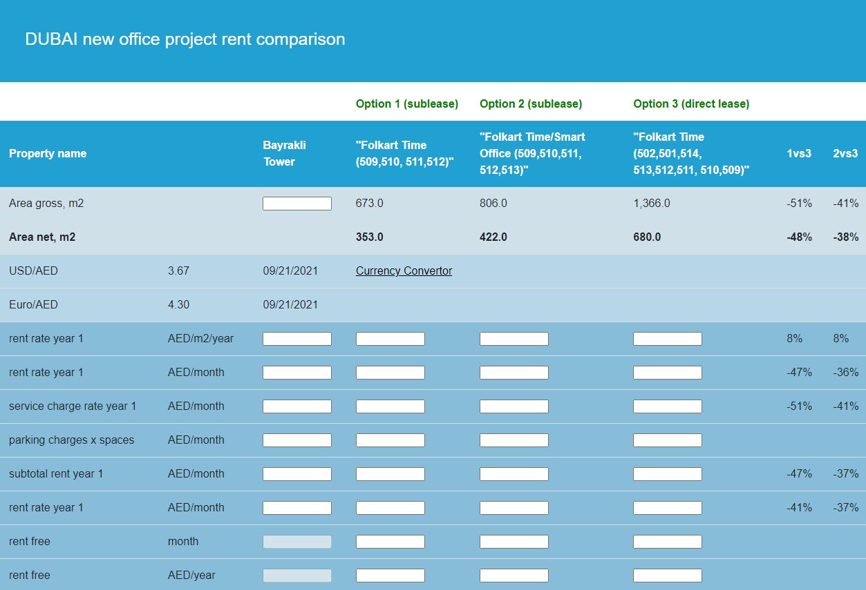

**Chapter 8**

**SOFTWARE TESTING**

Software testing is a process of executing a program or application with the intent of finding the software bugs. It can also be stated as the process of validating and verifying that a software program or application or product Meets the business and technical requirements that guided it design and development. Testing is a process rather than a single activity. This process starts from test planning then designing test cases preparing for execution and evaluating status till the test closure. So we can divide the activities within the fundamental test process into the following basic steps

# Planning and Control.

Testing is required for an effective performance of software application or product. It important to ensure that the application should not result into any failures because it can be very expensive in the future or in the later stages of the development. It required to stay in the business. software testing is necessary because we all make mistakes. Some of those mistakes are unimportant but some of them are expensive or dangerous. We need to check everything and anything we produce because things can always go wrong humans make mistakes all the time.

Since we assume that our work may have mistakes hence we all need to check our own work. However some mistakes come from broad assumptions and blind spots so we might make the same mistakes when we check our own work as we made when we did it.

So we may not notice the flaws in what we have done. Ideally we should get someone else to check our work because another person is more likely to spot the flaws. There are several reasons which clearly tells us as why Software Testing is important and what are the major things that we should consider while testing of any product or application. Software testing is very important because of the following reasons

# Software Component

Software testing is really required to point out the defects and errors that were made during the development phases. Its essential since it makes sure of the Customers reliability and their satisfaction in the application. It is very important to ensure the Quality of the product. Quality product delivered to the customers helps in gaining their confidence. Know more about Software Quality Testing is necessary in order to provide the facilities to the customers like the delivery of high quality product or software application which requires lower maintenance cost and hence results into more accurate consistent and reliable results. Testing is required for an effective performance of software application or product. Its important to ensure that the application should not result into any failures because it can be very expensive in the future or in the later stages of the development. Its required to stay in the business.

Software testing is an investigation conducted to provide stakeholders with information about the quality of the product or service under test.Software testing can also provide an objective independent view of the software to allow the business to appreciate and understand the risks of software implementation. Test techniques include the process of executing a program or application with the intent of finding software bugs errors or other defects and verifying that the software product is fit for use.

Software testing involves the execution of a software component or system component to evaluate one or more properties of interest. In

general these properties indicate the extent to which the component or system under test meets the requirements that guided its design and development responds correctly to all kinds of inputs performs its functions within an acceptable time is sufficiently usable can be installed and run in its intended environments and achieves the general result its stakeholders desire. As the number of possible tests for even simple software components is practically infinite all software testing uses some strategy to select tests that are feasible for the available time and resources. As a result software testing typically (but not exclusively) attempts to execute a program or application with the intent of finding software bugs (errors or other defects). The job of testing is an iterative process as when one bug is fixed it can illuminate other deeper bugs or can even create new ones. Software testing can provide objective independent information about the quality of software and risk of its failure to users or sponsors.Software testing can be conducted as soon as executable software (even if partially complete) exists. The overall approach to software development often determines when and how testing is conducted. For example in a phased process most testing occurs after system requirements have been defined and then implemented in testable programs. In contrast under an Agile approach requirements programming and testing are often done concurrently.

# 

# Alpha and Beta testing

Alpha testing is a type of acceptance testing; performed to identify all possible issues/bugs before releasing the product to everyday users or public. The focus of this testing is to simulate real users by using blackbox and whitebox techniques. The aim is to carry out the tasks that a typical user might perform. Alpha testing is carried out in a lab environment and usually the testers are internal employees of the organization. To put it as simple as possible this kind of testing is called alpha only because it is done early on near the end of the development of the software and before beta testing.

Beta Testing of a product is performed by ”real users” of the software application in a ”real environment” and can be considered as a form of external user acceptance testing. Beta version of the software is released to a limited number of end-users of the product to obtain feedback on the product quality. Beta testing reduces product failure risks and provides increased quality of the product through customer validation.It is the final test before shipping a product to the customers. Direct feedback from customers is a major advantage of Beta Testing. This testing helps to tests the product in real time environment.

Alpha Testing and Beta Testing are the common terms used in software industries and both have their scope and significance in testing practice. I would like to explain this with a simple example as follows. Whenever firms like Microsoft or IBM launch their software product in market it undergoes both Alpha and Beta Testing before it is available for end user. Lets say these reputed firms are launching their new operating system in the market so before launching of an operating system an organization conducts testing in two phases known as Alpha Testing phase and Beta Testing phase.

In Alpha Testing phase testing is conducted by a team of highly skilled testers at onsite whereas in Beta Testing phase this tested software product is made available to the customers or the end users to test the actual functionality and give their feedback.

Alpha Testing is a type of testing conducted by a team of highly skilled testers at development site whereas Beta Testing is done by customers or end users at their own site.For Alpha Testing there is a dedicated test team this is not the case with Beta Testing.Unlike Beta Testing Alpha Testing is not open for market or public. Alpha Testing is done for software

application project and product whereas Beta Testing is usually done for software product like operating system write or paint utilities games etc. Both alpha and Beta Testing are the kind of acceptance testing only difference is former is conducted within organization whereas latter in conducted out of organization. Since Alpha Testing is done onsite therefore developers as well as business analyst are involved with the testing team whereas in Beta Testing developers and business analysts are not at all involved.

Beta testers can be naive or proficient end users of software product but alpha testers are always high skilled professional testers.Alpha Testing involves both black box testing as well as white box testing. Beta Testing is always a black box testing or functional testing. Alpha Testing is done before the launch of software product into the market whereas Beta Testing is done at the time of software product marketing.Alpha Testing is conducted in the presence of developers and in the absence of end users whereas for Beta Testing this is exactly reversed. Since Beta Testing is done by end users therefore it is also known as field testing but there is no such other name for Alpha Testing.Both Alpha Testing and Beta Testing are also known as user acceptance testing (UAT) and the only difference here is former testing is conducted onsite but the latter testing is conducted offshore.Alpha Testing may be conducted in virtual environments; however Beta Testing is always conducted in Real Time environments with end users

# 8.4 Entry and Exit criteria

## 8.5 Entry Criteria for Alpha testing

Software requirements document or Business requirements specification Test Cases for all the requirements Testing Team with good knowledge about the software application Test Lab environment setup QA Build ready for execution Test Management tool for uploading test cases and logging defects Traceability Matrix to ensure that each design requirement has alteast one test case that verifies it

## Exit Criteria for Alpha testing

All the test cases have been executed and passed. All severity issues need to be fixed and closed Delivery of Test summary report Make sure that no more additional features can be included Sign off on Alpha testing

## 

## Entrance criteria for Beta Testing

Sign off document on Alpha testing Beta version of the software should be ready Environment ready to release the software application to the public Tool to capture real time faults

## Exit Criteria for Beta Testing

All major and minor issues are closed Feedback report should be prepared from public Delivery of Beta test summary report

# 8.4 Advantages and Disadvantages

## 8.4.0 Advantages Beta Testing

Reduces product failure risk via customer validation. Beta Testing allows a company to test launch infrastructure. Improves product quality via customer feedback Cost effective compared to similar data gathering methods Creates goodwill with customers and increases customer satisfaction

## 8.4.1 Disadvantages Beta Testing

Test Management is an issue. As compared to other testing types which are usually executed inside a company in a controlled environment beta testing is executed out in the real world where you seldom have control. Finding the right beta users and maintaining their participation could be a challenge

## 8.3.4 Advantages of Alpha Testing

Provides better view about the reliability of the software at an early

stage Helps simulate real time user behavior and environment. Detect many showstopper or serious errors Ability to provide early detection of errors with respect to design and functionality

## 8.3.5 Disadvantages of Alpha Testing

In depth functionality cannot be tested as software is still under development stage Sometimes developers and testers are dissatisfied with the results of alpha testing

# 

# Types Of Testing

There are many types of testing like

Unit Testing Integration Testing Functional Testing System Testing Stress Testing Perfor- mance Testing Usability Testing Acceptance Testing Regression Testing Beta Testing

## Unit Testing

Unit testing is the testing of an individual unit or group of related units. It falls under the class of white box testing. It is often done by the programmer to test that the unit he/she has implemented is producing expected output against given input.

## Integration Testing

Integration testing is testing in which a group of components are combined to produce output. Also the interaction between software and hardware is tested in integration testing if software and hardware components have any relation. It may fall under both white box testing and black box testing.

## Functional Testing

Functional testing is the testing to ensure that the specified functionality required in the system requirements works. It falls under the class of black box testing.

## System Testing

System testing is the testing to ensure that by putting the software in different environments ( Operating Systems) it still works. System

testing is done with full system implementation and environment. It falls under the class of black box testing.

## Stress Testing

Stress testing is the testing to evaluate how system behaves under unfavorable conditions. Testing is conducted at beyond limits of the specifications. It falls under the class of black box testing.

## 

## Performance Testing

Performance testing is the testing to assess the speed and effectiveness of the system and to make sure it is generating results within a specified time as in performance requirements. It falls under the class of black box testing.

## Usability Testing

Usability testing is performed to the perspective of the client to evaluate how the GUI is user- friendly? How easily can the client learn? After learning how to use how proficiently can the client perform? How pleasing is it to use its design? This falls under the class of black box testing.

## Acceptance Testing

Acceptance testing is often done by the customer to ensure that the delivered product meets the requirements and works as the customer expected. It falls under the class of black box testing.

## Regression Testing

Regression testing is the testing after modification of a system component or a group of related units to ensure that the modification is working correctly and is not damaging or imposing other modules to produce unexpected results. It falls under the class of black box testing.

**Chapter 9**

**FEEDBACK**

Feedback occurs when outputs of a system are routed back as inputs as part of a chain of cause-and-effect that forms a circuit or loop. The system can then be said to feed back into itself. The notion of cause-and-effect has to be handled carefully when applied to feedback systems: ”Simple causal reasoning about a feedback system is difficult because the first system influences the second and second system influences the first, leading to a circular argument. This makes reasoning based upon cause and effect tricky, and it is necessary to analyze the system as a whole.”

To improve the qualitative data obtained from software engineering experiments by gather- ing feedback during experiments. Rationale Existing techniques for collecting quantitative and qualitative data from software engineering experiments do not provide sufficient information to validate or explain all our results.

Therefore, we would like a cost effective and unobtrusive method of collecting feedback from subjects during an experiment to augment other sources of data. Design of study We formulated a set of qualitative questions that might be answered by collecting feedback during software engineering experiments.

We then developed a tool to collect such feedback from experimental subjects. This feedback collection tool was used in four different experiments and we evaluated the usefulness of the feedback obtained in the context of each experiment. The feedback data was triangulated with other sources of quantitative and qualitative data collected for the experiments. Results We have demonstrated that the collection of feedback during experiments provides useful additional data to validate the data obtained from other sources about solution times and quality of solutions check process conformance understand problem solving processes identify problems with experiments and understand subjects perception of experiments. Conclusions Feedback

collection has proved useful in four experiments and we intend to use the feedback collection tool in a range of other experiments to further explore the cost effectiveness and limitations of this technique.It is also necessary to carry out a systematic study to more fully understand the impact of the feedback collecting tool on subjects performance in experiments.

There are two types of feedback positive feedback and negative feedback.

# Positive and Negative Feedback

## Positive Feedback

Positive feedback occurs when the fed back signal is in phase with the input signal. Under certain gain conditions, positive feedback reinforces the input signal to the point where the output of the device oscillates between its maximum and minimum possible states. Positive feedback may also introduce hysteresis into a circuit. This can cause the circuit to ignore small signals and respond only to large ones. It is sometimes used to eliminate noise from a digital signal. Under some circumstances, positive feedback may cause a device to latch, i.e., to reach a condition in which the output is locked to its maximum or minimum state. This fact is very widely used in digital electronics to make bistable circuits for volatile storage of information. The loud squeals that sometimes occurs in audio systems, PA systems, and rock music are known as audio feedback. If a microphone is in front of a loudspeaker that it is connected to, sound that the microphone picks up comes out of the speaker, and is picked up by the microphone and re amplified. If the loop gain is sufficient, howling or squealing at the maximum power of the amplifier is possible.

## 

## 9.1.2 Negative Feedback

A Negative feedback occurs when the fed back output signal has a relative phase of 180 with respect to the input signal (upside down). This situation is sometimes referred to as being out of phase, but that term also is used to indicate other phase separations, as in ”90

out of phase”. Negative feedback can be used to correct output errors or to desensitize a system to unwanted fluctuations. In feedback amplifiers, this correction is generally for waveform distortion reduction or to establish a specified gain level. A general expression for the gain of a negative feedback amplifier is the asymptotic gain model.

**Bibliography**

h[ttps://www.w3](http://www.w3schools.com/bootstrap/default.asp)scho[ols.com/b](http://www.w3schools.com/bootstrap/default.asp)o[otstrap/default.asp.](http://www.w3schools.com/bootstrap/default.asp).

h[ttps://www.w3](http://www.w3schools.com/php/default.asp)scho[ols.com/php/default.asp.](http://www.w3schools.com/php/default.asp)

h[ttps://www.w3](http://www.w3schools.com/html/default.asp)scho[ols.com/html/default.asp.](http://www.w3schools.com/html/default.asp)

h[ttps://www.w3](http://www.w3schools.com/sql/default.asp)scho[ols.com/sql/default.asp.](http://www.w3schools.com/sql/default.asp)